

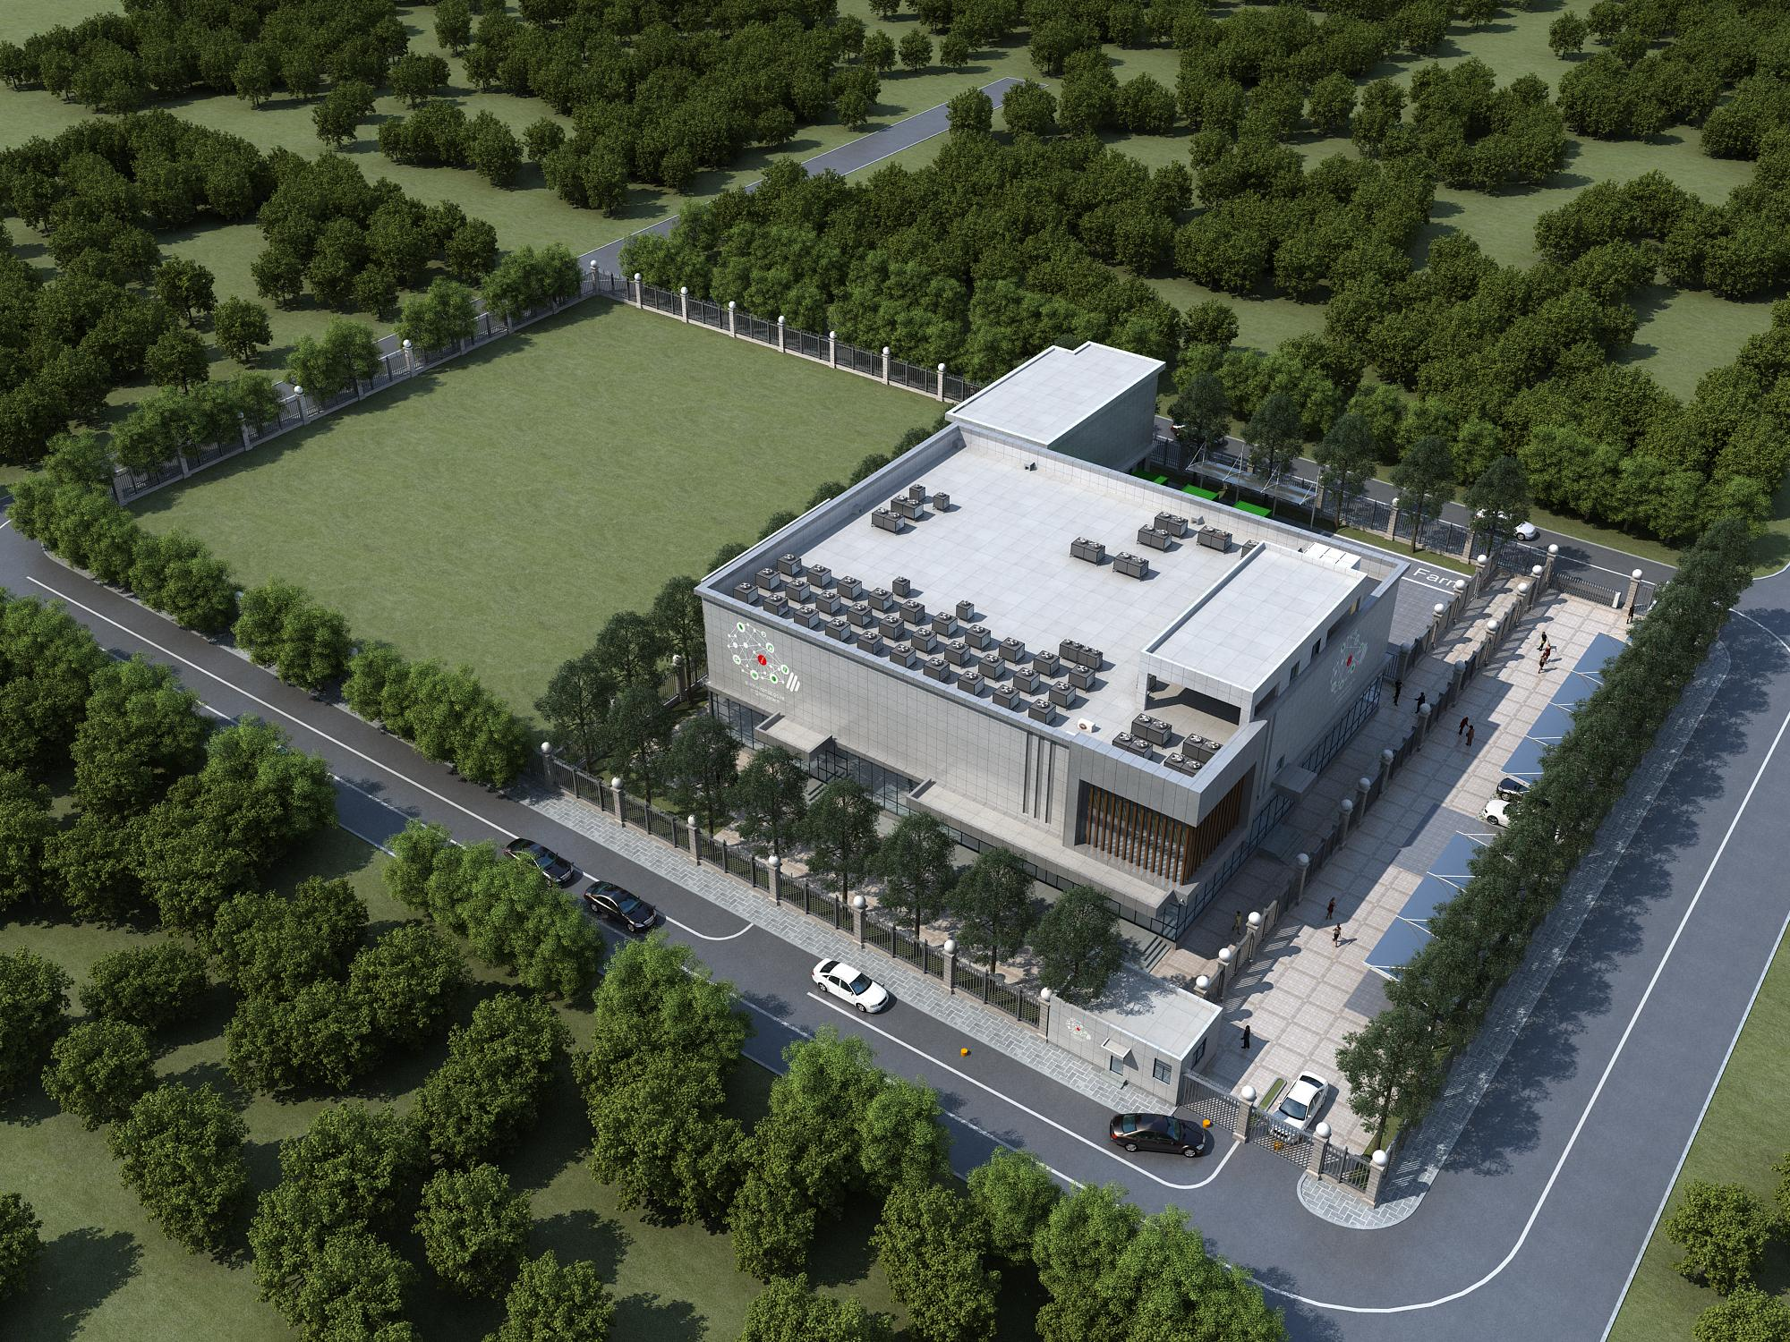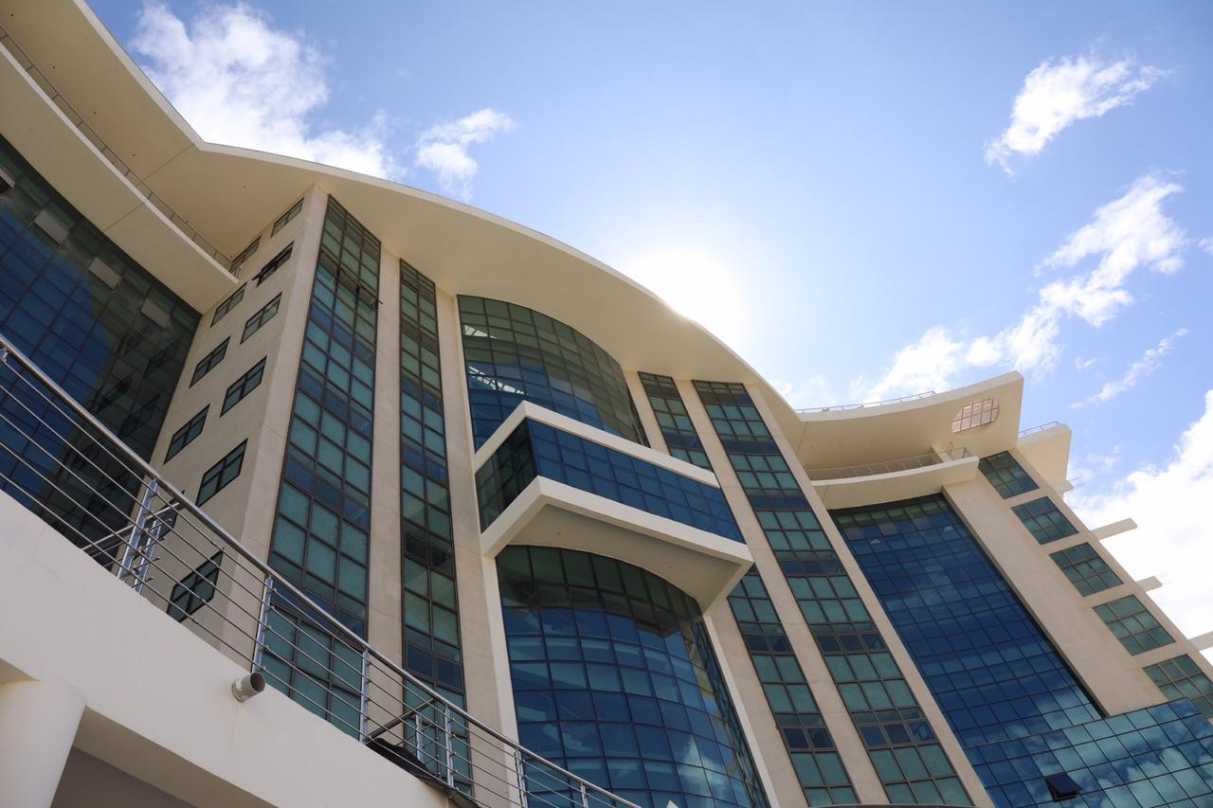

Konza National Data Centre & Smart City Facilities

Konza Complex *(Office Block)*



Horizontal Infrastructure through EPC-F

**Project Management Policy**

**2024**

**KONZA TECHNOPOLIS DEVELOPMENT AUTHORITY**

Contents

Definitions of Key Terminology 4

FOREWORD 6

OUR IDENTITY 6

Revision History 7

Approvals 8

Introduction 9

Purpose of Policy 9

Objectives of the Policy 9

Applicability 10

Guiding Principles of the Policy 10

Project Initiation and Approval 10

Project Funding 10

Project Management 10

Project Manager/Project Coordinator 10

Project Client/User Department 10

Project Planning 10

Project Monitoring and Controlling 11

Risk Management 11

Project Completion 12

Post-Project Implementation Review 12

Project Governance 12

Policy statement 13

Policy Review date 13

This policy will be reviewed every two years or earlier as may be dictated by circumstances. 13

Policy effective date 13

# Definitions of Key Terminology

|  |  |
| --- | --- |
| **Project** | A temporary endeavour with distinct start and end dates that progresses through defined phases and adheres to a formal project management methodology undertaken to create a unique product, service or result |
| **Program** | Projects that are grouped together to achieve a common solution to a foreseen business requirement or strategic priority |
| **Project Management** | The discipline of planning, organizing, securing and managing resources to bring about the successful completion of specific project objectives. |
| **Project Manager** | The role responsible for the day-to-day leadership and management of the project objectives, tasks and the project team. |
| **Project Management Office (PMO)** | A function that is intended to build an organization’s project management capability by fostering a community of project management practitioners that promotes collaboration and sharing of information among project managers. |
| **Project Sponsor** | The role that has overall responsibility for ensuring that a project meets its objectives and delivers the projected benefits |
| **Project Stakeholder** | a party with an interest in the execution and outcome of a project |
| **Project Governance** | A comprehensive, consistent method of controlling the project and ensuring its success by defining, documenting and communicating reliable, repeatable project practices. |
| **Project lifecycle** | a series of phases that a project passes through from its initiation to its closure, and provides the basic framework for managing the project |
| **Project Phase** | Grouping of similar activities within the project lifecycle. Phases are sequential in that one phase should be largely completed before the next phase of the project is started. |
| **Project Team** | The group that is responsible for supporting a project by contributing skills and knowledge to the project as required and passing on project information to respective stakeholders as appropriate |
| **Project Implementation Committee** | The key governing body within the project governance structure that guides the overall project implementation, and strategic direction and endorses recommendations to the Chief Executive Officer |
| **Business Case** | A document based on an operational or strategic need that has been identified from within a business unit, to provide justification for undertaking a project and outline key information such as objectives, benefits and funding of the proposed project. |
| **Benefits Realisation Analysis** | the process of identifying, executing, and measuring benefits. A benefit is the measurable improvement resulting from an outcome perceived as an advantage by one or more stakeholders |
| **Risk** | A threat to the successful delivery of a project has a higher likelihood of becoming an issue without appropriate mitigation strategies being put in place. |
| **Risk Register** | A record of identified risks relating to a project, including their status, impact and mitigation strategies |
| **Issue** | A crystalized risk, i.e. a problem or concern that has emerged and if not addressed is expected to affect the project schedule or outcomes |
| **Issue Register** | A document that captures and maintains information on all formal project issues and is monitored by the Project Manager throughout the project |
| **End of Phase Report** | A document used to show how a project phase has performed against targets and the changes that should be made to subsequent phases to achieve the project outcomes |
| **Post Implementation Review** | A review that is conducted after a project is completed to ensure that the project has met its objectives and the outcomes meet the requirements of users and stakeholders |

# FOREWORD

The management of Konza Technopolis Development Authority recognizes the critical role of ethical service and professionalism in service delivery in addition to concerted efforts from staff as a means to achieve the Authority’s mission, vision, and mandate.

To promote transparency and accountability in the Authority, it is important to define the Authority standards of practice to regulate behaviors, interactions, and actions of its members of staff. The management recognizes unethical and unprofessional conduct as impediments to social and economic development which also undermines confidence in public institutions

The KoTDA PMO policy outlines guidelines under which Konza projects will be executed, how procedures will be carried out while executing the projects and the best practices to be adopted.

To inform the standards of practice stipulated in this code, this document takes cognizance of the Authority’s vision, mission, values, and mandates. It also incorporates the statutory provisions of the various acts namely: The Survey Act, the Land Act 2012, The Land Registration Act, The Public Procurement and Disposal Act 2015, The Public Officer Ethics Act 2003, The Civil Service Code of Regulations revised 2006, The Public Service Commission Act cap 185, The Anti – Corruption and Economic crimes Act 2003 and other relevant regulations. To create a physical environment that fosters corporate innovation to further our goal of developing a smart city, it is important to have a free social environment.

I therefore call for a concerted effort from our staff, stakeholders, investors, development partners and the community to support the Authority through adherence to this policy. Any incidence of unethical practices should be reported to the Authority.

Signed _____________________ Date: _______________________

Mr. John Paul Okwiri, OGW

**CHIEF EXECUTIVE OFFICER**

# 

# OUR IDENTITY

**Vision**

To be a leading global Technopolis and innovation hub

**Mission**

To develop a thriving sustainable smart city and a vibrant innovation ecosystem contributing to Kenya’s knowledge Economy

**Mandate**

The mandate of KoTDA is to develop Konza Technopolis as a globally competitive smart city by

creating an enabling environment through the utilization of ICT for socioeconomic development

**Strategic objectives**

* + - Develop and manage a world-class smart city with a vibrant, safe secure, healthy and sustainable ecosystem.
    - Form partnerships with other actors in the National Innovation System, to recruit, attract, and develop high-end talent as well as create relevant, and smart innovative solutions and commercialize them.
    - Mobilise adequate and sustainable funding to meet the Authority’s mandate and changing needs of the business community and residents.
    - Create a strong brand and image of Konza Technopolis that will attract, facilitate and retain investors.
    - Ensure that the Authority has the adequate institutional capacity to fulfill its mandate.

# Revision History

Other versions existing:

|  |  |  |  |
| --- | --- | --- | --- |
| **Document title** | **Version History** | **Approved** | **Comments** |
| PMO Policy | Version 0 |  |  |

# Approvals

|  |  |  |  |
| --- | --- | --- | --- |
| Name | Title | Comment | Signature and Date |
|  |  |  |  |
|  |  |  |  |

# **Introduction**

The Konza Technopolis Project Management Policy outlines guidelines for undertaking all projects within the Authority that must be understood by all staff and other stakeholders that will be involved in the projects. It also provides procedures upon which the policy shall be administered and best practices to be adopted.

The Authority will keep the Project Management Policy current and relevant. Therefore, from time to time it may be necessary to modify or amend particular sections of this policy or add new procedures as deemed necessary.

## Purpose of policy

This policy outlines the principles and responsibilities associated with managing projects at Konza Technopolis Development Authority (KoTDA). The expected outcome of implementing this policy is to increase organization-wide project success through the management and implementation of a best practice-based project management methodology, and the establishment of defined processes that measure and evaluate project progress throughout the project lifecycle.

This document describes the essential elements in the management of all projects to establish an organization-wide approach that follows the five stages of the project management cycle as set out by the Project Management Institute (PMI) in its guidelines published in the –PMBOK Guide namely: -Initiation, Planning, Execution, Monitoring and Control, and Closure.

## Objectives of the Policy

The objective of this policy is to ensure that:

1. Projects are effectively managed within the limitations of scope, schedule, budget, quality, and risk.
2. Appropriate governance and control of projects is established across all KoTDA projects.
3. Successful delivery of project outcomes aligned to organizational strategic priorities and objectives are achieved.
4. Communication, quality and risk management plans are adhered to throughout a project’s lifecycle.
5. Appropriate change authorization and acceptance procedures are adhered to throughout the life of a project.
6. Projects Stakeholders' engagement is comprehensive.
7. Post-implementation reviews are conducted and documented to be used to improve the performance and delivery of future projects.

## Applicability

This policy applies to all KoTDA Capital Projects. All officers must have regard for this policy in the context of project initiation and planning, monitoring and controlling, risk management and stakeholder engagement.

## Guiding Principles of the Policy

The principles of Project Management are the fundamental rules that shall be followed for the successful management of projects.

## Project Initiation and Approval

All KoTDA projects shall be initiated at the Planning division of KoTDA in collaboration with the planning divisions of MOIC & DE and The National Treasury. This is recommended for major projects where external entities would be key stakeholders. The submission shall include the name of the project, the purpose of the project, costs, funding details, name of the Project Manager, risks associated with the project, brief statements on objectives to be achieved, alternative approaches, specific benefits (financial and non-financial), key stakeholders, critical timelines the completion target date.

## Project Funding

The project funding shall be negotiated/agreed upon by the Planning division of KoTDA in collaboration with the planning divisions of MOIC&DE and The National Treasury before any commitments are entered into.

## Project Management

### Project Manager/Project Coordinator

Each project shall have a Project Coordinator who is a staff of the Project Management Office (PMO), responsible for the day-to-day management of projects, including budgets and liaising with all project stakeholders. The Project Coordinator shall report to the Project Manager, who is the head of the Project Management Office (PMO).

### Project Client/User Department

Each project shall have a Project Client or User Department whose responsibility is to define the project objectives and ensure the project deliverables are consistent with the set objectives.

## Project Planning

The Project Coordinator shall set out the project plan at the beginning of the project in agreement with the Project Manager. The Project Coordinator shall work in collaboration with the Finance team on the preparation and monitoring of the budget. The Finance team shall regularly update the PMO on payments made to keep tabs on the progress of the budget vs project progress. The Finance department shall keep and make available records of all project payments for project reporting.

## Project Monitoring and Controlling

The Project Coordinator, in consultation with the Project Manager, shall formulate a monitoring and controlling process for each project. This shall involve formulating monthly meetings, standard agendas and project reports highlighting project schedule, project cost vs budget, project variations and project issues. The Project Manager shall generate regular reports to the Management and the Board that approved the project.

## Risk Management

Best practice highlights the need for the active management of risk throughout the life of the project, with particular attention to time and cost overruns and/or risks that would lead to failure to deliver a successful project outcome. The use of a risk register is a key tool for managing risk and it should be reviewed and updated continually throughout the life of the project. The Project Coordinator shall maintain a risk register for each project, and discuss and update it periodically during divisional meetings. The Project Coordinator shall make the register available to the Risk Audit team for use in organizational risk review.

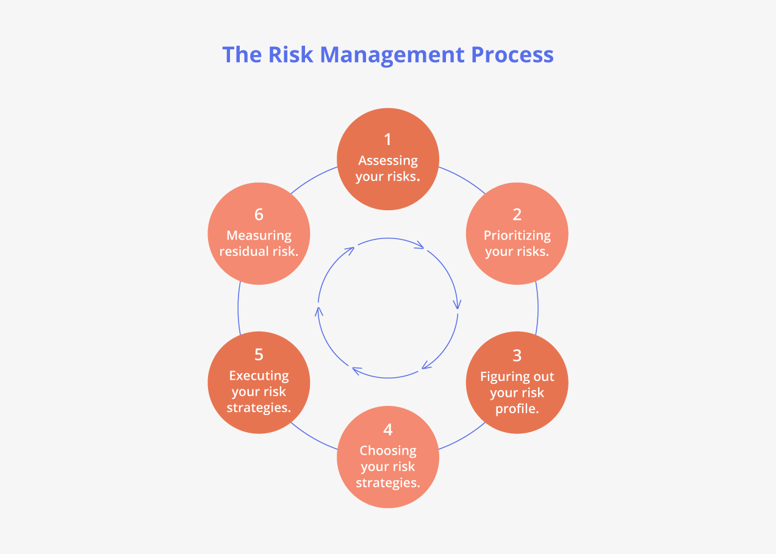

## Project Completion

The Project Coordinator shall prepare a report on the completed project highlighting the objectives achieved, Project cost vs budget, and Project schedule status vs original baseline. The project completion report shall demonstrate that;

* the objectives identified in the Project Brief have been met
* the final budgetary position
* any follow-up actions or lessons learned
* request for formal sign-off
* the project has been handed over to the end user.

All project documentation shall be archived appropriately.

## Post-Project Implementation Review

Post-project Implementation Review is carried out to assist project managers in knowing if a particular project proved effective, and whether to cancel, continue, or modify future projects. It helps to guide the funding and planning of future programs during the annual budget cycle and to equip managers with crucial information to improve the performance of projects.

The Post-Project Implementation Review (PIR) shall be carried out by the PMO team in collaboration with User departments or project clients.

## Project Governance

The successful delivery of KoTDA projects is dependent on clearly defined roles, accountabilities and responsibilities of all project stakeholders, with defined controls and decision-making processes. The PMO shall put in place governance structures for each project, which shall follow established principles of good governance as identified below:

* Roles and responsibilities – shall be clearly defined for individuals as well as groups within the project governance structure
* Scope and Project Objectives - a clearly defined scope and project objectives shall be established and adapted as required in response to the needs of every project.
* Risk – recognition and management of an appropriate system of risk management shall be put in place.
* Project performance - clear performance indicators shall be established to assess performance and to provide markers of good and poor performance
* Integrity and accountability - transparency and accountability mechanisms for fair and proper decision-making shall be put in place.
* Culture and ethics - establish a culture of ethical and responsible decision-making.
* Stakeholder Engagement – an effective mechanism for engagement with all project stakeholders as deemed appropriate to their involvement in the project shall be put in place
* Decision making – that issues are resolved efficiently, effectively, transparently and consistently applied across all projects.

## Policy statement

The Project Management Office (PMO) utilizes the universal principles of the PMBOK® guide as an overarching Project Management Framework, in conjunction with this policy and associated procedure. This framework for Project Management is based on the generic process flows of Initiating, Planning, Executing, Controlling & Monitoring and Closing.

Project management activities, goals and outcomes shall align with the organization’s strategic and operational plans including performance measures and annual budget.

## Policy Review date

This policy will be reviewed every two years or earlier as may be dictated by circumstances.

## Policy effective date

This policy shall become effective on approval by the full Board of Directors.