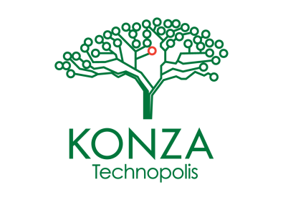

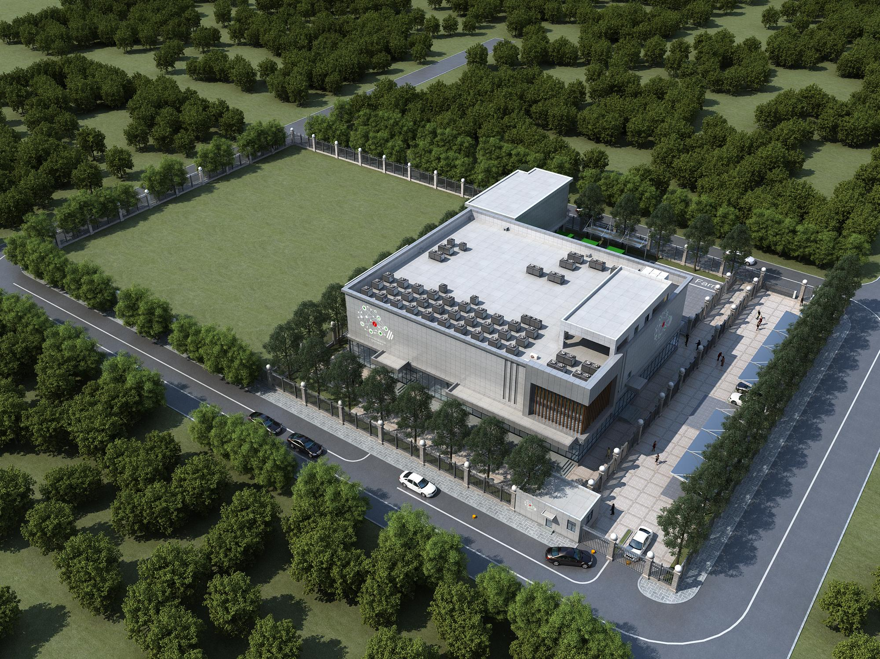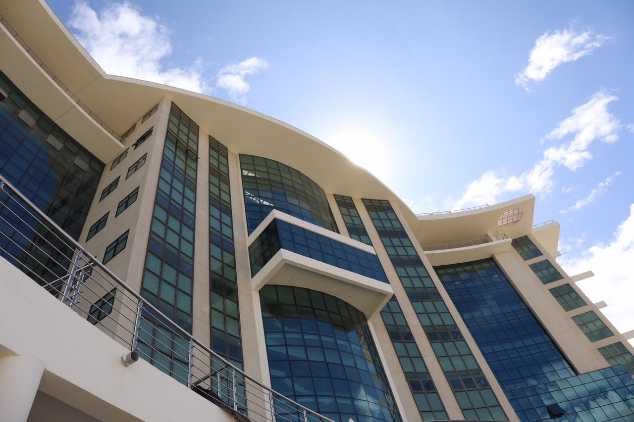

Konza National Data Centre & Smart City Facilities

Konza Complex *(Office Block)*

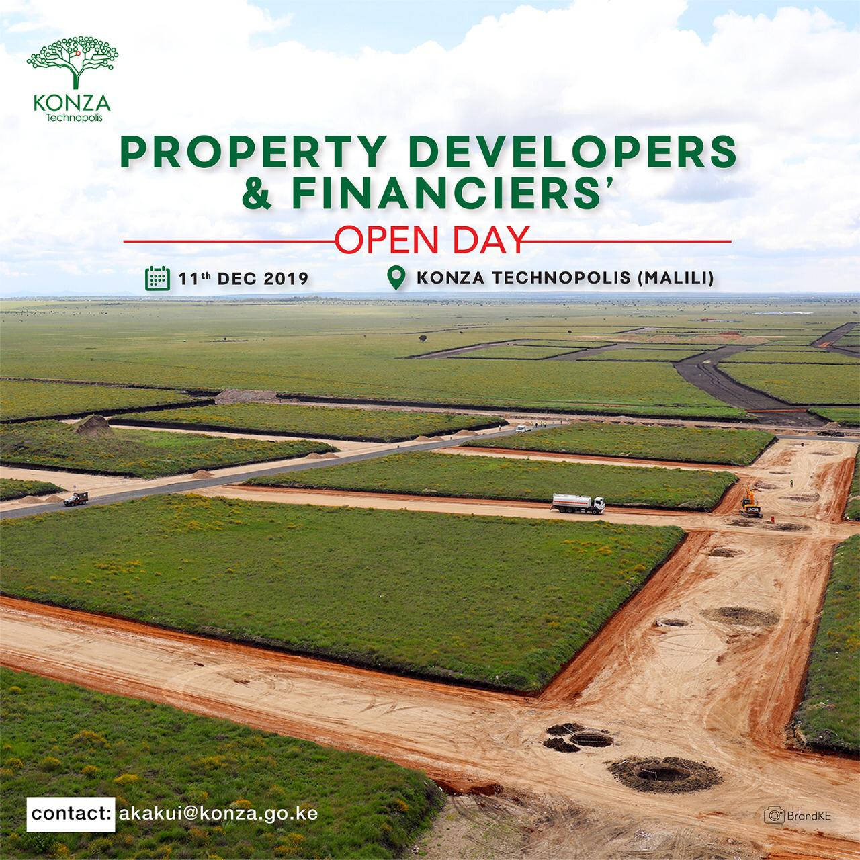

Horizontal Infrastructure through EPC-F

**RESEARCH POLICY**

**FEBRUARY 2024**

**KONZA TECHNOPOLIS DEVELOPMENT AUTHORITY**

# RESEARCH POLICY REVIEW SHEET

|  |  |  |  |  |
| --- | --- | --- | --- | --- |
| Issue/Revision No | Subject of Amendment | Reviewed By | Authorized By | Date |
|  |  |  |  |  |
|  |  |  |  |  |
|  |  |  |  |  |
|  |  |  |  |  |
|  |  |  |  |  |
|  |  |  |  |  |
|  |  |  |  |  |
|  |  |  |  |  |
|  |  |  |  |  |
|  |  |  |  |  |
|  |  |  |  |  |
|  |  |  |  |  |
|  |  |  |  |  |
|  |  |  |  |  |
|  |  |  |  |  |

# TABLE OF CONTENTS

RESEARCH POLICY REVIEW SHEET ii

TABLE OF CONTENTS 1

FOREWARD 3

KONZA TECHNOPOLIS IDENTITY 4

Vision 4

Mission 4

Mandate 4

Core Values 4

Strategic Objectives 4

LIST OF ABBREVIATIONS 5

1 INTRODUCTION AND BACKGROUND 6

1.1 Introduction 6

1.2 Policy Statement 6

1.3 Objectives of the Policy 6

1.4 The scope of the policy 6

1.5 Research Priority Areas 6

1.6 Policy Rationale 7

1.7 KoTDA Research Principles 7

1.8 Research Protocol 7

1.9 Management of Research 7

1.10 Requirements to Undertake Research 8

1.11 Research Output 8

1.12 Publication Guidelines 9

1.13 Research Committee 9

1.14 Composition of Research Committee 9

1.15 Mandate of the Research Committee 9

1.16 Research Partnerships 9

1.17 Commercialization of Research 10

2 ETHICAL CONSIDERATIONS 10

2.1 Research Code of Ethics 10

2.2 The Researcher and Participants in the Research Process 10

3 INTELLECTUAL PROPERTY PUBLICATION AND INTELLECTUAL PROPERTY 11

4 ANNEX 1: RESEARCH REQUEST FORM 1

# FOREWARD

Konza Technopolis is a key flagship project of Kenya’s Vision 2030 economic development portfolio that aims to transform Kenya into a newly industrializing middle-income country by 2030. Konza Technopolis will create high-value jobs, contribute to the country’s GDP by focusing on Research, Development and Entrepreneurship in the Science Technology and Innovation (STI) sector. The development of the Konza Technopolis is established on three critical clusters that define the functional specialization of Konza as a “Technopolis” The core clusters include ICT/ITES, Life Sciences, and Engineering that will be mainly driven by research and development, education, and commercial development.

Research is a key component in advancing the role of ST&I. Konza Technopolis is strategically positioning itself to center its efforts on the effective commercialization of research outcomes. The primary goal is to create an environment where research findings can be transformed into viable commercial products and services, thereby driving innovation and economic growth. This focus on commercialization will be the linchpin of Konza Technopolis' success, attracting partners and investors who are committed to bridging the gap between research and market-ready solutions.

To enhance the Authority's relevance and facilitate well-informed decision-making in alignment with the city's smart and sustainable aspirations, Konza Technopolis will implement a comprehensive research policy that adheres to NACOSTI's National Research Priorities.

I thus request a dedicated effort from all stakeholders, including staff, innovators, students, and any other interested parties, to assist KoTDA in implementing this policy.

……………………………………… Dated …………………………………….

Mr. John Okwiri

**Chief Executive Officer**

# KONZA TECHNOPOLIS IDENTITY

## Vision

To be a leading global Technopolis and innovation hub.

## Mission

To develop a thriving sustainable smart city and a vibrant innovation ecosystem contributing to Kenya’s knowledge economy.

## Mandate

The mandate of KoTDA is to develop Konza Technopolis as a globally competitive smart city by creating an enabling environment through the utilization of ICT for socio-economic development.

## Core Values

1. Nurturing
2. Innovation
3. Collaboration
4. Excellence

## Strategic Objectives

* Develop and manage a world-class smart city with a vibrant, safe and secure, healthy, and sustainable ecosystem.
* Form partnerships with other actors in the National Innovation System, to recruit, attract, and develop high-end talent as well as create relevant, and smart innovative solutions and commercialize them.
* Mobilize adequate and sustainable funding to meet the Authority’s mandate and changing needs of the business community and residents.
* Create a strong brand and image of Konza Technopolis that will attract, facilitate, and retain investors.
* Ensure that the Authority has the adequate institutional capacity to fulfil its mandate.

# LIST OF ABBREVIATIONS

**KoTDA**  Konza Technopolis Development Authority

**RC** Research Committee

**ICT**  Information Communication and Technology

**ITES**  Information Technology-Enable Services

**IP** Intellectual Property

**ST&I** Science Technology and Innovation

**GDP**  Gross Domestic Product

# INTRODUCTION AND BACKGROUND

## Introduction

The KoTDA research policy provides the guiding principles, general framework, and relevant tools which illustrate the key features of the Authority’s research process. The policy specifies the guiding principles for all people participating in research at Konza Technopolis in terms of management, support, and development.

## Policy Statement

The Authority is dedicated to advancing research excellence and facilitating the effective commercialization of research outputs. This commitment is upheld through the cultivation of a culture centered on relevant research, the proactive promotion and dissemination of valuable research outputs, the regular review and enhancement of our research policy, the recognition of exceptional research performance, and the assurance of efficient research management.

## **Objectives of the Policy**

The main objective of this policy is to establish consistency and transparency in the processes of research planning, execution, monitoring, evaluation, and the dissemination of research outputs. The Authority aims to

1. To equip, encourage and motivate staff , Partners and students to conduct research.
2. To develop a framework to upscale and commercialize research outputs and innovations.
3. To enhance research skills among staff.
4. To Increase the quantity and relevance of research output.
5. To safeguard Intellectual Property Rights.
6. Establish rational, transparent, and collective decision-making processes.

## **The scope of the policy**

The KoTDA research policy establishes guiding principles and essential tools to demonstrate the key elements of the Authority's research process. In terms of administration, support, and development, the policy applies to everyone conducting research at Konza Technopolis. This includes all KoTDA staff, attaches and Interns. It also applies to anyone who is not associated with KoTDA who wishes to conduct research at Konza Technopolis, as well as students and/or relevant stakeholders who are involved in KoTDA’s research.

## **Research Priority Areas**

The Authority's research focus areas will be informed by the Authority's strategic plan, annual work plan, stakeholder feedback, current national policy, NACOSTI, and research priorities (e.g., Kenya Vision 2030 and MTPs, Constitution of Kenya, 2010), and relevant regional and international policy considerations.

## **Policy Rationale**

The purpose of this policy is to ensure that there is a consistent, organization-wide approach to Research at KOTDA and within Konza Technopolis.

## **KoTDA Research Principles**

Konza Technopolis affirms the following principles concerning research:

1. The authority’s departments, staff, and partners are free to select the subject matter of their research and to form their findings and conclusions.
2. Any individual, organization, or partner seeking to conduct Research at Konza Technopolis shall inform the Corporate Research and Strategy department of the intention. The Authority through the Department may restrain research efforts that may violate the principles of the Research policy.
3. All research conducted at Technopolis shall make available the findings and conclusions for the study findings.
4. Research techniques should not violate established professional ethics about the health, safety, privacy, and other personal rights of human beings.
5. Konza Technopolis shall foster a conducive research environment. In the instances where the Technopolis is limited because of inadequate resources, it will allocate space, facilities, and other resources for research programs based on the priority focus of the Authority’s projects and the necessity of the proposed research.
6. The authority shall partner with individuals and institutions to advance research of mutual interest based on the authority’s Mandate.

## **Research Protocol**

Any internal research undertaken at the Technopolis shall be documented and filed. External stakeholders who expresses interest in conducting research at the Technopolis are required to fill a research request form. The research request form is attached here in.

## **Management of Research**

At KoTDA, active research management takes place at departmental level. CRP&S's role is to promote and support research by:

1. Creating an environment that encourages and supports effective research.
2. Developing research skills and competence among staff and external stakeholders: these important aspects of personal development shall have a positive impact on Kenya’s knowledge economy.
3. Encouraging all departments, and staff interest and participation in research events e.g., conferences, panel discussions, research workshops, etc.

## **Requirements to Undertake Research**

KoTDA recognizes the importance of research, hence all employees are encouraged to participate in research activities.

1. All KoTDA employees have the right to conduct research, engage in scholarly activity, and publish their findings.
2. The responsibility for monitoring the research portfolio lies with the Authority, which will engage in negotiations with department heads regarding the distribution of their activities. This will be done through the Corporate, Research, Policy, and Strategy Department. The Authority's research priorities will be clearly outlined in the yearly work plan. Departments will be required to update research programs in annual work plans, monitor the activities contained therein, and provide a copy of these plans to the CRP&S research committee on an annual basis.
3. The Authority acknowledges that the aforementioned objectives cannot be proven to have been achieved without the dissemination of high-quality research findings to the public or, in the event of sensitive material, to be kept confidential. The Authority commits to providing effective, efficient, and equitable support for researchers through the infrastructure, publicizing KoTDA research successes, advising on research areas, and publicizing and coordinating internal and external policy matters related to research.

## **Research Output**

The Authority shall recognize the following output but will not be limited to:

1. Quarterly research papers,
2. Publications made to external research conferences.
3. Research publications done in Konza
4. Konza Research Journal

## **Publication Guidelines**

All employees involved in publishing must exercise extreme caution when using material written by others and ensure that it is properly acknowledged. Plagiarism is defined as the deliberate copying of another person's work and presenting it as one's own. This is unacceptable at the authority. Those who use material that was not created by them are responsible for making its status and origins clear to those to whom it is presented.

## **Research Committee**

The primary responsibility of the Research Committee (RC) is to initiate, coordinate, and appraise research, as well as to assist with infrastructure and encourage the publication of results in recognized sources. The committee will be in charge of making certain that quality standards are meet. The purpose of this Research Committee is to promote the Authority’s research.

## Composition of Research Committee

The committee shall be made up of any member of staff with research experience. Any department can have a member. It is suggested that there be a minimum of four and a maximum of twelve members. The committee can elect a chairperson, a deputy chairperson, and a secretary from among its members.

## Mandate of the Research Committee

1. Promote KoTDA's research activities.
2. Assists departments and other external stakeholders pursuing research at KoTDA with protocols related to research initiatives.
3. Assist in the creation of research infrastructure.
4. Encourage researchers to publish their findings.
5. Evaluation of internal research funding requests.
6. Monitoring of progress reports

## Research Partnerships

The Authority recognizes the important role of national and international research partnerships in driving innovation and research. Our commitment to these collaborations empahsized in our mission, where partnerships serve as an important channel for research capacity enhancement.

1. Creating an Enabling Environment for Sustainable Partnerships

The Authority shall actively cultivate an environment that nurtures and sustains research partnerships. This includes facilitating student and professional exchange programs, and providing platforms for researchers, institutions, and companies to collaboratively identify research challenges and co-create problem-solving partnerships.

## Commercialization of Research

Our commitment to research commercialization and innovation is reflected in this policy. It is aligned with our guiding principles and it provides a solid foundation for collaboration with partners. It serves as a catalyst for translating research outcomes into tangible products, services, and solutions that benefit society and the economy.

The Authority shall promote research commercialization by, but not limited to, the following measures:

1. **Supporting Innovation and Entrepreneurship**

KoTDA shall actively encourage and supports innovation and entrepreneurship arising from research endeavors.

1. **Technology Transfer and Industry Collaboration**

The Authority shall facilitate the seamless transfer of technology and knowledge through partnerships with businesses and industries to bridge the gap between research and commercial application.

1. **Protection of Intellectual Property**

The Authority shall ensure the protection of intellectual property in reference to the Authority’s IP policy.

1. **Economic and Societal Impact:**

The Authority shall prioritize initiatives that have the potential to generate significant benefits for both the Authority and the country.

# ETHICAL CONSIDERATIONS

## Research Code of Ethics

The KoTDA research code outlines the Authorities' principles , which all KoTDA researchers/research groups connected with KoTDA shall adhere to in their work. KoTDA shall conduct and promote research to develop practical answers to problems and, as a result, contribute to Kenya’s Knowledge economy. The research conducted will take into consideration the society and the

research participants.

## The Researcher and Participants in the Research Process

1. When preparing and carrying out a study, the researcher should constantly consider the research's ethical acceptability as well as the likely implications.
2. When it's suitable, the researcher tells participants about all aspects of the study, including its goals and ramifications, that could have an impact on their willingness to participate.
3. Individuals' right to refuse to participate in research and to terminate their participation at any time is respected by the researcher.
4. Unless the participant agrees to its publication, information gathered in the course of the study that may expose a participant's identity is treated as confidential.

# INTELLECTUAL PROPERTY PUBLICATION AND INTELLECTUAL PROPERTY

1. All research shall adhere to the KoTDA IP Policy , and acts that KoTDA has adopted.
2. The policy will always recognize and apply national laws on intellectual property and its protection.
3. All inventions for which the originator reasonably believes they will be of economic interest or value to KoTDA through Cooperate Research Policy and Strategy must be disclosed.
4. For all study findings, KoTDA shall keep a database at the Cooperate Research Policy and Strategy Office. The research findings may be preserved in the KoTDA research journal, and resource centre, among other platforms.
5. With permission from the author and/or KoTDA, all KoTDA research findings and publications, whether hard copies, electronic copies, audio typing, will be available in the KoTDA Resource Centre for use by staff members for research and learning purposes. The material must be available for electronic or photocopier copying unless copyrights prohibit it.
6. If someone has any suspicions that a KoTDA staff member or other KoTDA members have engaged in Misconduct in Research, the established complainant procedures will be investigated.

|  |  |
| --- | --- |
| **Implementing Unit** | Corporate Research, Policy, and Strategy Department |
| **Effective Date** |  |
| **Review Date** |  |
| **Policy Version/ Revision History** | 00 |
| **Scope of Policy Application** | All KoTDA Stakeholders |
| **Approval by the CEO:** |  |
| **Approval by the Board of Directors:** |  |

# ANNEX 1: RESEARCH REQUEST FORM

**KONZA TECHNOPOLIS DEVELOPMENT AUTHORITY**

KoTDA RESEARCH REQUEST FORM

**REQUEST TO CONDUCT RESEARCH IN KONZA TECHNOPOLIS**

1. **PARTICULARS OF THE RESEARCHER**

|  |  |  |
| --- | --- | --- |
| ***1.1*** | **Details of the Researcher** | |
| ***First Name/s:*** | |  |
| ***Title (Prof / Dr / Mr / Mrs / Ms):*** | |  |
| ***Student Number (if relevant):*** | |  |
| ***ID Number:*** | |  |
| ***Passport no. (If not a KE citizen)*** | |  |
| ***Contact Number*** | |  |
| ***Email*** | |  |

1. **PURPOSE & DETAILS OF THE PROPOSED RESEARCH**

|  |  |  |  |  |
| --- | --- | --- | --- | --- |
| ***2.1*** | | **Purpose of the Research (Please tick where appropriate)** | | |
| ***Undergraduate Study - Self*** | | |  | |
| ***Postgraduate Study - Self*** | | |  | |
| ***Partnership with KoTDA*** | | |  | |
| ***Private Research by Independent Researcher*** | | |  | |
| ***Non-Governmental Organization*** | | |  | |
| ***Independent Research Agencies*** | | |  | |
| ***2.2*** | | **Full title of Thesis / Dissertation / Research Project** | | |
|  | | | | |
|  | | | | |
| ***2.3*** | | **Primary Objective of the Research** | | |
|  | | | | |
|  | | | | |
| ***2.4*** | ***Time frames*** | | | **Date** |
| ***Envisaged date of* completion of research in Konza:** *(dd/mm/yy)* | | | |  |
| ***Envisaged date of* submission of the Research Report and**  **Research Summary to KoTDA:** *(dd/mm/yy)* | | | |  |

1. **METHODOLOGY SUGGESTED (Please tick)**

(Please indicate by placing a tick in the appropriate block whether the following modes would be adopted)

|  |  |  |
| --- | --- | --- |
|  |  | ***Please tick*** |
| Qualitative: | Focus groups |  |
|  | In-depth interviews |  |
|  |  |  |
| Quantitative: | Face-to-face interviews |  |
|  | Telephone interviews |  |
|  | Self-completion questionnaire |  |
|  |  |  |
| Mixed methods: (Explain shortly) | | |
|  | | |

1. **TARGET RESPONDENTS**

State the target population for the research, as well as the geographical areas to be covered.

______________________________________________________________________________________________________________________________________________________________________________________________________________________________________________________________________________________________________________________________________________________________________________________________________

1. **EXPECTED DELIVERABLES**

Tick your needs with regard to the following possibilities:

|  |  |  |
| --- | --- | --- |
|  | **Yes** | **No** |
| PowerPoint presentation |  |  |
| Raw data (tables for quantitative research; transcripts for qualitative research) |  |  |
| A written detailed report (bound and electronic copies) |  |  |

**Any other comment on deliverables:**

____________________________________________________________________________________________________________________________________________________________________________________________________________________________________________________________________________________________________________________________________________________________________________________________________________________________________________________________________________________________________________________________________

1. **SAFETY CONSIDERATIONS**

Kindly indicate any safety considerations that will be required while undertaking research at Konza.

____________________________________________________________________________________________________________________________________________________________________________________________________________________________________________________________________________________________________________________________________________________________________________________________________________________________________________________________________________________________________________________________________

1. **SECURITY CONSIDERATIONS**

Kindly highlight any security measures that might be considered while undertaking your research.

____________________________________________________________________________________________________________________________________________________________________________________________________________________________________________________________________________________________________________________________________________________________________________________________________________________________________________________________________________________________________________________________________

**ACKNOWLEDGEMENT**

By submitting this research request form, I acknowledge that I have read and understood Konza Technopolis Development Authority's policies regarding research, and I agree to abide by them. I also understand that submission of this form does not guarantee approval of my research project.

Signature: ________________________________

Date: ________________________________

**ACCEPTED / NOT ACCEPTED**

**Comments:** *(To be issued by KoTDA)*

____________________________________________________________________________________________________________________________________________________________________________________________________________________________________________________________________________________________________________________________________________________________________________________________________________________________________________________________________________________________________________________________________